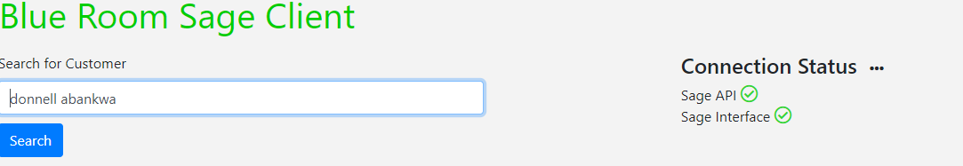

**SCS Sales Enquiry Screen**



